

Save Time and Money with   
Next-Generation Video Game Software

# INTRODUCTION

Image source: minecraft.net

There’s no question that the indie game scene has exploded in the last decade. Arguably, the catalyst behind this boom was the passion project of a Swedish game programmer: *Minecraft.* To an independent game developer, the phenomenal success of *Minecraft* is an alluring Cinderella story. “If their love for game development launched them to incredible success, then why not mine, too?”

Not just the popularity, but the accessibility of indie games has also dramatically improved in the 2010’s. While there’s plenty of credit owed to distribution platforms like Steam, the main reason for the newfound ease of indie game development is the accessibility of new and old video game engines.

# GAME ENGINES

So, what IS a video game engine?

Unity puts it best: “A game engine is the software that provides game creators with the necessary set of features to build games quickly and efficiently” (Unity, “Game Engines”).

In the good ol’ days (up until the late 1980s), game developers would program games from scratch, tailoring their code to the specific output of the hardware. As the hardware would evolve, the code would be come useless and have to be discarded (Lowood).

Enter DOOM (1993)—not the first game to use an engine, but the first to define it. Its “engine” is a set of code that is transferrable across different hardware and abstracts the design process—that is, puts the process on a level that’s easier to understand by the layperson.

With engines, game design is much easier. That said, engines were practically exclusive to AAA game developers for more than ten years.

# THE MODERN PROBLEM

Game engines are no longer restricted to the titans of the video game industry. Many of those said titans have created powerful engines that are available for public use at some cost (unique to each engine).

The problem is this: transferring projects across game engines is either extremely inefficient or downright impossible without starting over. So, one of if not *the* first problem indie developers face when creating a game is deciding on what engine to use. After all, once you choose, you are committed to that decision.

That decision is a bit more intimidating than it appears, judging by the small number of engines listed on this page.







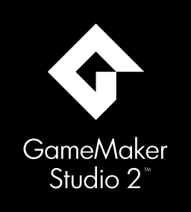

# WHAT’S THE BEST VIDEO GAME ENGINE?

Let’s dispense with this idea immediately: there is no “best” video game engine. There is always one better specialized to whatever task you have in mind, or perhaps an engine whose workflow just clicks with you better. But, all those variables equal, what engine stands above its peers?

The ideal game engine would fit the following criteria:

1. **Widely-used.** While an engine being popular obviously speaks for its quality on its own, popularity also leads to more common and more specialized documentation online, and more peers to communicate with when learning the ropes of the engine or after running into a roadblock down the line.
2. **Inexpensive.** As an independent developer, paychecks aren’t necessarily a sure thing. Cutting costs where possible can save you some lunch money later on.
3. **Easy to learn.** Whether you’re a programmer or want to learn engine-specific visual scripting, user-friendly documentation is one of the most important factors to learning what the engine can do.
4. **Has an impressive track record.** That is, many popular games have been developed using this engine. If you look at an engine’s list of releases and recognize a beloved game on that list, that likely speaks to the engine’s capabilities.
5. **Is useful to your needs.** There is no getting around this: you need to have a vision for your project beforehand, and you need to know what you want out of the engine. This part is on you.

# HISTORY OF UNREAL ENGINE 4

*All other considerations equal, Epic Games’ Unreal Engine 4 is the best engine out there for independent game developers.*

The “Unreal Engine” is named after the first game to use it: 1998’s *Unreal* (Lowood). The engine has been iterated repeatedly as hardware evolves, with each large milestone earning the engine a new number at the end. Currently, Unreal Engine’s fourth iteration is the latest and greatest version.

While originally only used in-house by Epic Games (the engine’s creator), in 2014, Unreal Engine 4 (henceforth UE4) was released publicly with a monthly paid subscription and a 5% cut of revenue earned by games created using the engine (Orland, 2014). Later the same year, free copies of the engine were granted to accredited universities (Batchelor, 2014).

In March 2015, Epic Games announced a change that still holds today: UE4 is **free to use**, with the only caveat being the 5% cut of revenue earned by games using the engine—and even then, this only affects games that gross $3000 or more in a fiscal quarter (Nutt, 2015).

“UE4 is free to use.”



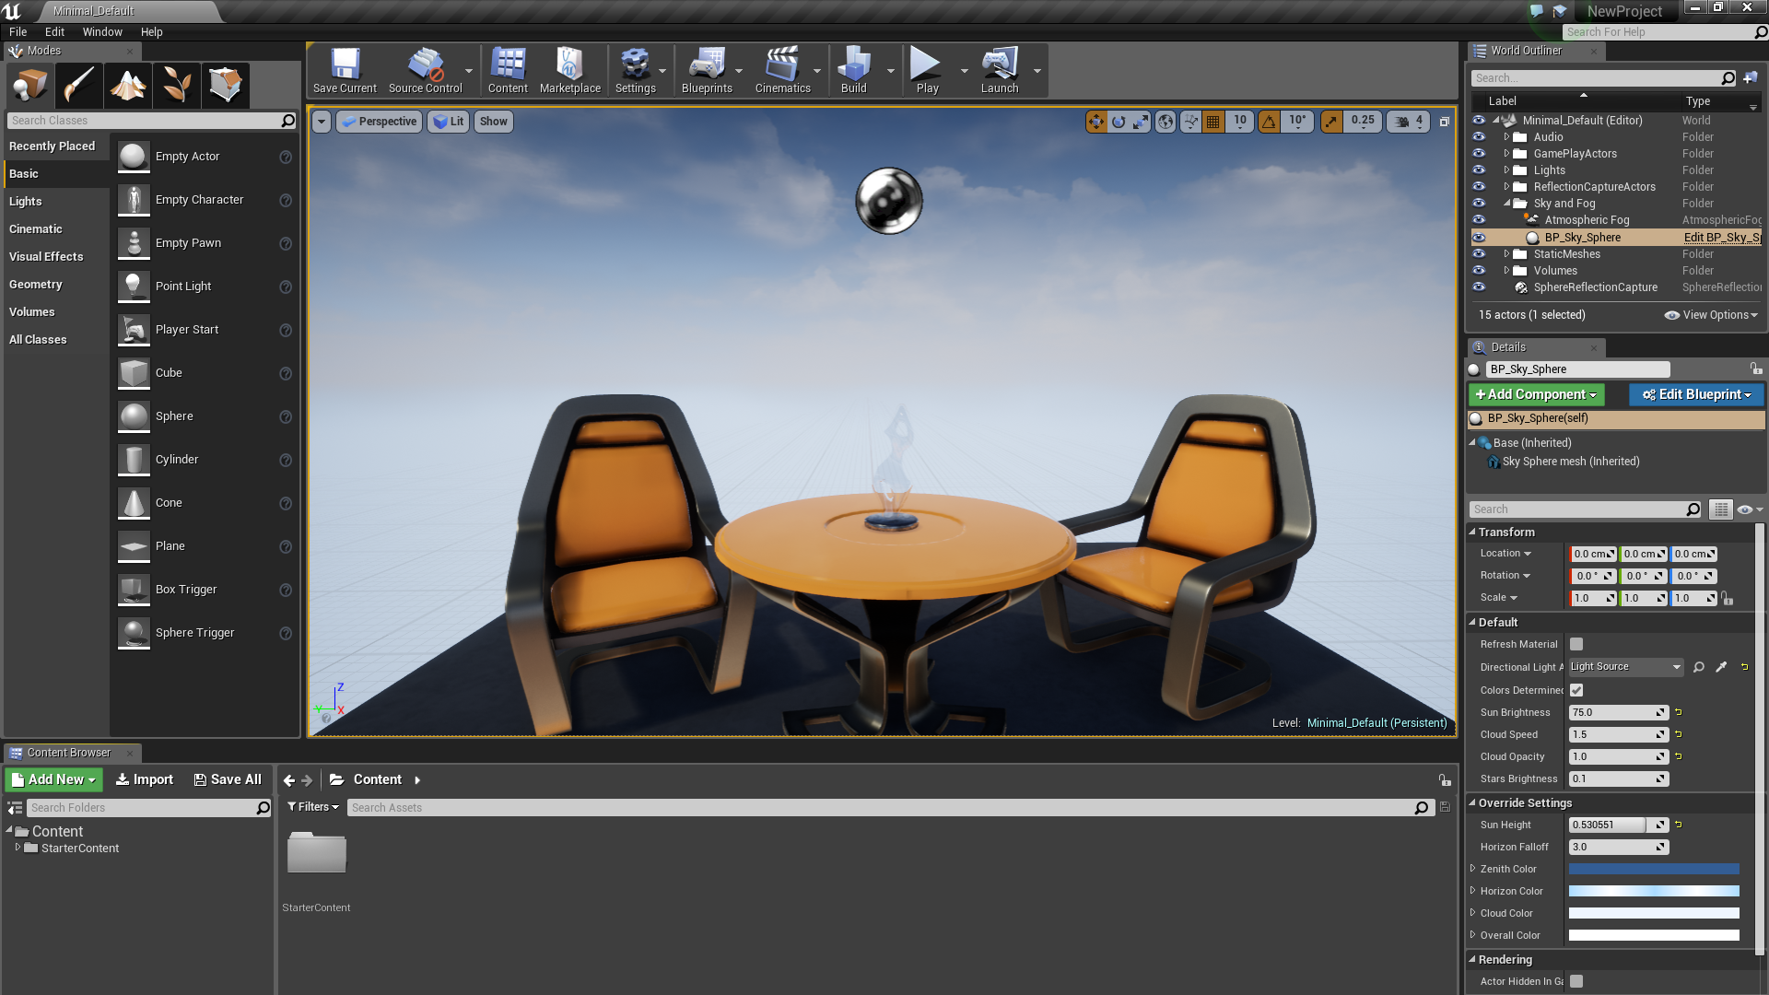

*Unreal Engine 4's main interface. Image source: UE4 docs*

# WHY UNREAL ENGINE 4 IS THE ANSWER

## 1. Widely-used

Over 200 notable games using UE4 either have been completed or are in development (“List”), and its official subreddit has over 40,000 active users.

## 2. Inexpensive

As mentioned previously, UE4 is free to download, and all of its features are available from the start. The caveat is the 5% royalty Epic Games claims on profitable games (Nutt, 2015).

## 3. Easy to learn

Part of UE4’s claim to fame is its Blueprint Visual Scripting, which abstracts the coding process into easily-digestible chunks while not sacrificing the versatility of code. Entire games can be programmed using Blueprints without touching a single line of code (Epic Games). This significantly lowers the barrier to entry.

In addition, official documentation exists online, which features many step-by-step guides that ease users into Blueprint Visual Scripting and normal C++.

## 4. Noteworthy track record

Unreal Engine 4 is one of the most popular engines even among AAA developers, such as Rare, Square Enix, and Capcom—not to mention Epic’s own library of games.

Notable recent releases include Square Enix’s *Octopath Traveler,* Arc System Works’ *Dragon Ball FighterZ,* and Epic’s own *Fortnite.*



## 5. Pertains to your needs

This is the most important point, and also the most subjective. Unreal Engine 4 is a powerful, simple, popular, and usable engine, but it still might not be the engine you need. Plenty of other engines could be equally- or better-suited for the game you have in mind.

# COMPARISONS





Unity is UE4’s closest competitor in terms of popularity, capabilities, and library of games. Its primary programming language is C#, which a developer may prefer over UE4’s C++ (Unity, “The world’s”).

Unity is also notorious for having a large and active forum community, even more so than UE4’s. Similarly, Unity’s documentation is also lauded as superior over UE4’s.

Unity does have a free “Personal” version, but some features are limited to the paid version. The paid version of Unity uses a monthly subscription of either $35 or $125 a month, depending on the subscription type (Unity, “Unity Store”).

While UE4’s main strength is in 3D games, Unity holds 3D and 2D at the same level and has notable releases in both styles.

Some of Unity’s most noteworthy games include *Ori and the Blind Forest, Cuphead,* and *Pokémon Go.*

**

GameMaker Studio (GMS) is one of if not the most popular engine for making 2D games. It has a user-friendly drag-and-drop feature for making simple games, but it is better known for its “GameMaker Language”, a scripting language unique to the engine (YoYo Games, “Features”). Developers well-versed in scripting languages like JavaScript may find themselves at home with GMS.

GMS has a free trial for users to get the hang of the engine before committing to a purchase. Instead of using a subscription plan, the full engine is obtainable as one-off purchases starting at $99.99, depending on the system you are developing for (McKeand, 2016).

Notable games made using GMS include *Spelunky, Rivals of Aether,* and *Undertale.*

## RPG Maker/SRPG Studio/etc.

GameMaker Studio, Unity, and Unreal Engine 4 are all *generalized* engines: their purpose is to give a broad assortment of tools with maximum leeway so that developers can create whatever kind of game they want if they put in the legwork. Engines like RPG Maker take a different approach: they target a specific genre of game and tailor the creation experience around that. In the case of RPG Maker, perhaps the most well-known of these specialized engines, the experience is entirely focused on the creation of 2D turn-based RPGs.

RPG Maker MV, the latest version of the engine, is a one-time $79.99 purchase (Romano, 2018). It has a trial version with most of its features greatly limited.

Notable games made using RPG Maker include *Yume Nikki, Lisa: The Painful,* and *To the Moon*.

# CONCLUSION

While there are dozens of viable game engines for any independent project, Unreal Engine 4 is the perfect mix of powerful, cost-efficient, and user-friendly.

*To learn more, visit* [*https://www.unrealengine.com/en-US/what-is-unreal-engine-4*](https://www.unrealengine.com/en-US/what-is-unreal-engine-4) *by scanning the QR code below and download the latest version for free.*

**

# CITATIONS

Batchelor, J. (2014, September 4). *Putting Unreal Engine in the classroom.* Retrieved from <https://www.mcvuk.com/development/putting-unreal-engine-in-the-classroom>

Epic Games. *About Unreal Engine 4.* Retrieved from <https://www.unrealengine.com/en-US/features>

Lowood, H. *Game Engines and Game History.* Retrieved from <https://www.kinephanos.ca/2014/game-engines-and-game-history/>

*List of Unreal Engine games.* Retrieved from <https://en.wikipedia.org/wiki/List_of_Unreal_Engine_games#Unreal_Engine_4>

McKeand, K. (2016, November 4). *GameMaker Studio 2 enters beta.* Retrieved from <https://www.pcgamesn.com/gamemaker-studio-2-beta>

Nutt, C. (2015, March 2). *Unreal Engine 4 is now free-to-download for everyone.* Retrieved from <http://www.gamasutra.com/view/news/237724/Unreal_Engine_4_is_now_freetodownload_for_everyone.php>

Orland, K. (2014, March 19). *Unreal Engine 4 now available as $19/month subscription with 5% royalty.* Retrieved from <https://arstechnica.com/gaming/2014/03/unreal-engine-4-now-available-as-19month-subscription-with-5-royalty/>

Romano, S. (2018, July 24). *RPG Maker MV for PS4, Xbox One, and Switch launches November 15 in Japan.* <https://gematsu.com/2018/07/rpg-maker-mv-for-ps4-xbox-one-and-switch-launches-november-15-in-japan>

Unity. *Unity Store.* Retrieved from <https://store.unity.com/?_ga=2.192868456.333887277.1544655179-1971723304.1538119635>

Unity. *Game engines—how do they work?* Retrieved from <https://unity3d.com/what-is-a-game-engine>

Unity. *The world’s leading real-time engine.* Retrieved from <https://unity3d.com/unity>

YoYo Games. *Features.* Retrieved from <https://www.yoyogames.com/gamemaker/features>